##$$CLODAT7 (Clusters of Orientation Data)
(Signifiaant separation of submaxima)

The program CLODAT7 recognises the formation of clusters in distributions of orientation data (Wallbrecher, 1986).
In the menu 'data input' you choose the drive which contains the data or 'manual' if you want to add new data.
Manual input is also possible for universal stage data like azimuths and tilt angles of axes (i.e. quartz-c-axes) or normals to planes (i.e. poles to mica-planes). These data are converted to azimuths of dip and angles of dip internally. All further processing of these data is done in this format.
The type of data must be set int the menu 'fabric type'. In the menu ‚angle’ you choose input in the 1..360° or 1..400gon scale.
For data input from a file the fabric types "U-stage-axes" and "U-stage-poles“ are not active, because U-stage data are saved in *.LIN files.
Data input from an EXCEL-sheet is also possible. In the sheet azimutth of dip and angle of dip may be written either in a single row (with a separation key) or in two separate rows.
##$$Clusters of Orientation Data, Plot:

Significant separation of clusters in the distribution is carried out.
The statistic parameters of the clusters found are calculated as shown in the program Fabric. Sperical aperture and cone of confidence are drawn with the cluster-centre (centre of gravity) as centre. In the menu confidence the probability level saved in Fabric7.ini can be changed.
In the menu colour the colours of all plot parameters saved in Fabric7.ini can be changed. In the menu ‚Symbol for data points' the plot symbol can be changed.
The menu ‚Diagram’ ist the same as in the other programs.
##$$KK>>Cluster

A cluster is an area in a distribution of orientation data in which the counting density is higher than in the surroundings. Such an area is also called 'maximum' or 'submaximum'. It resembles the 'mode' in normal statistics. A distribution with more than one cluster is polymodal.
##$$KK>>Significant Separation:

The data which belong to one cluster are found by drawing a cone with the apical angle τ around the direction of each data point. Data with overlapping cones belong to the same cluster. Cluster τ is the test angle, it depends on the counting density, which is shown in multiples of even distribution.
The statistical parameters of each cluster are calculated. Significant separation is given when the cones of spherical aperture + cone of confidence do not overlap with those of other clusters. Overlapping clusters are put together to 'pooled groups. The statistical parameters if these pooled groups are then calculated.
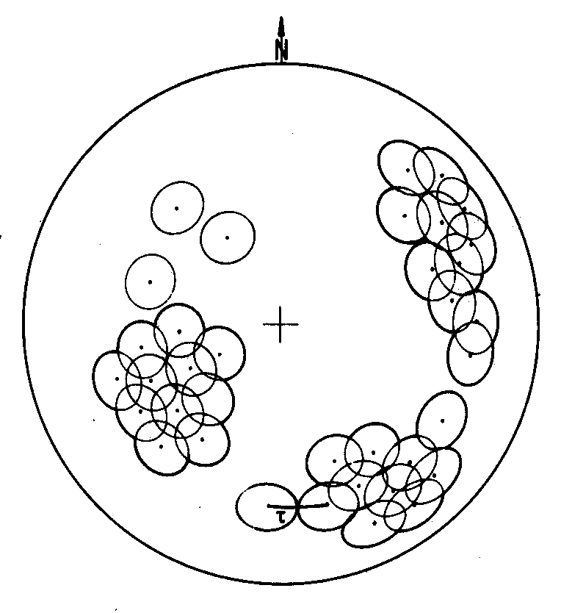
##$$KK>>Test Angle:

In the program CLODAT7 the test angle is the apical angle of the cone which is drawn around each data point in order to find those data which belong to a cluster. It is dependent on the size of the area for a multiple of even distribution. It is defined as

n = number of data
a = multiple of even distribution

The multiple of even distribution is saved in Fabric7.ini. It can be changed in the scroll field on the right side of the plot area.
##$$KK>>Pooled Group

In the program CLODAT7 a pooled group consists of the data of overlapping clusters.

# Clodat
$ Clodat
# ClodatPlot
$ ClodatPlot
# Cluster
$ Cluster
K cluster
> Hilfe1
# Trennung
$ Trennung
K significant separation
> Hilfe1
# Testwinkel
$ Testwinkel
K test angle
> Hilfe1
# Obergruppe
$ Obergruppe
K pooled group
> Hilfe1

